**Arduino Ohmmeter:**

We find it difficult to read color codes on resistors to find its resistance. In order to overcome the difficulty of finding the resistance value, we are going to build a simple **Ohm Meter using Arduino**. The basic principle behind this project is a voltage divider network. The value of the unknown resistance is disp layed on 16*2 LCD display.

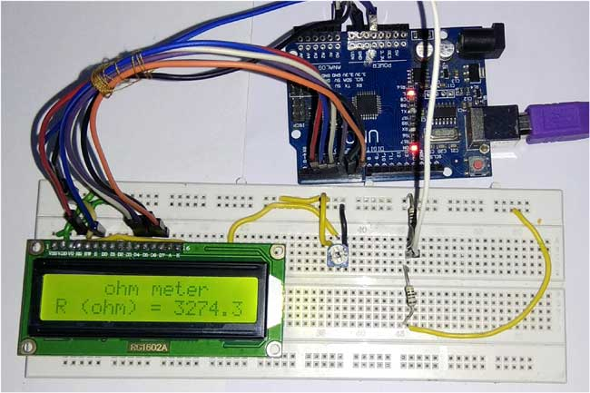

**Components Required:**

1. Arduino Uno
2. 16*2 LCD display
3. Potentiometer (1 kilo Ohm)
4. Resistors
5. Breadboard
6. Jumper wires

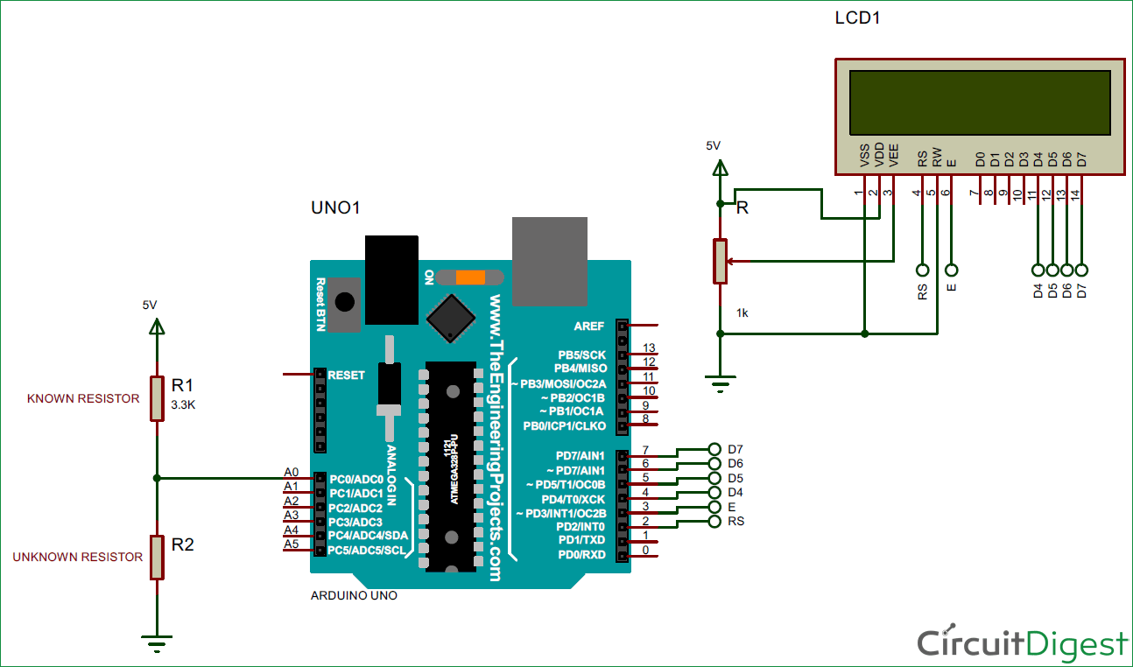

**Concept of Resistance Color Code:**

To identify the value of the resistance we can use the below formula.

R= { (AB*10c)Ω ± T% }

Where

           A = Value of the color in the first band.

           B = Value of the color in the second band.

           C = Value of the color in the third band.

           T = Value of the color in the fourth band.

The table below shows the color code of resistors.

|  |  |  |  |
| --- | --- | --- | --- |
| **Color** | **Numerical value of the color** | **Multiplication factor(10c)** | **Tolerance value(T)** |
| Black | 0 | 100 | - |
| Brown | 1 | 101 | ± 1% |
| Red | 2 | 102 | ± 2% |
| Orange | 3 | 103 | - |
| Yellow | 4 | 104 | - |
| Green | 5 | 105 | - |
| Blue | 6 | 106 | - |
| Violet | 7 | 107 | - |
| Gray | 8 | 108 | - |
| White | 9 | 109 | - |
| Gold | - | 10-1 | ± 5% |
| Silver | - | 10-2 | ± 10% |
| No band | - | - | ± 20% |

For example, if the color codes are**Brown – Green – Red – Silver,**the value of resistance is calculated as,

Brown = 1

Green = 5

Red = 2

Silver = ± 10%

From the first three bands, R = AB*10c

R = 15 * 10+2

R = 1500 Ω

Fourth band indicates tolerance of   ± 10%

10% of 1500 = 150

For + 10 percent, the value is 1500 + 150 = 1650Ω

For - 10 percent, the value is 1500 -150 = 1350Ω

Therefore the actual resistance value can be anywhere between 1350Ω to 1650Ω.

To make it more convenient here is the [Resistance Color Code Calculator](https://circuitdigest.com/calculators/resistor-color-code-calculator) where you only need enter the color of rings on resistor and you will get the resistance value.

**Calculating Resistance using Arduino Ohm Meter:**

The working of this **Resistance Meter** is very simple and can be explained using a simple [voltage divider network](https://circuitdigest.com/calculators/voltage-divider-calculator) shown below.

From the voltage divider network of resistors R1 and R2,

**Vout = Vin * R2 / (R1 + R2 )**

From the above equation, we can deduce the value of R2 as

**R2 = Vout * R1 / (Vin – Vout)**

Where R1 = known resistance

            R2 = Unknown resistance

            Vin = voltage produced at the 5V pin of Arduino

            Vout = voltage at R2 with respect to ground.

**Note:**the value of known resistance (R1) chosen is 3.3KΩ, but the users should replace it with the resistance value of resistor they have chosen.

So if we get the value of voltage across unknown resistance (Vout), we can easily calculate the unknown resistance R2. Here we have read the voltage value Vout using the analog pin A0 (see the circuit diagram) and converted those digital values (0 -1023) into voltage as explained in Code below.

If the value of the known Resistance is far greater or smaller than the unknown resistance the error will be more. So it is advised to keep the known resistance value nearer to the unknown resistance.